SPOOLer Simulation
COSC 2P13 – Final Project
Matt Laidman
5199807, ml12ef
April 6, 2015
Table of Contents
Assignment Outline 1
Objective 5
The Software 5
Usage 5
The Simulation 5
Print Job Creation 6
The Clock 6
Queue Implementations 6
Plots 7
Libraries Used 7
Known Issue 7
Analysis 8
Plots 8
Discussion 21
Comparisons 21
Conclusion 22
PrintSim Source Code 23
Simulate.java 23
SimClock.java 29
GraphData.java 30
PrintJob.java 31
Spooler.java 33
PrintQueue.java 34
NoSuchQueueException.java 36
Queue.java 37
QNode.java 38
FIFOQueue.java 39
SPJFQueue.java 41
PAPQQueue.java 43
LBAQQueue.java 45
QueueOverflowException.java 47
QueueUnderflowException.java 48
DNode.java 49
Citations 50

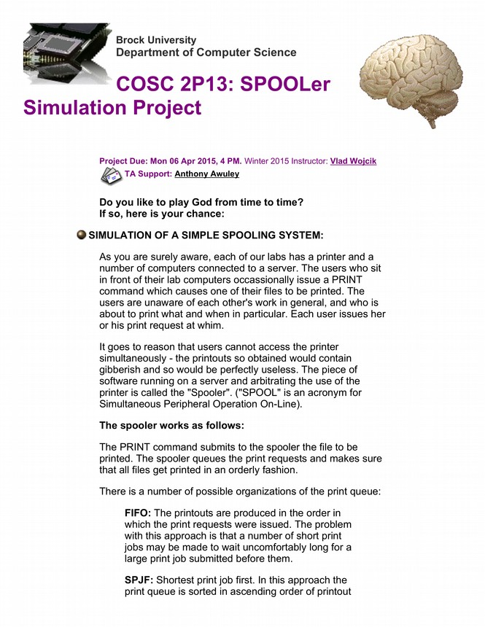
Assignment Outline
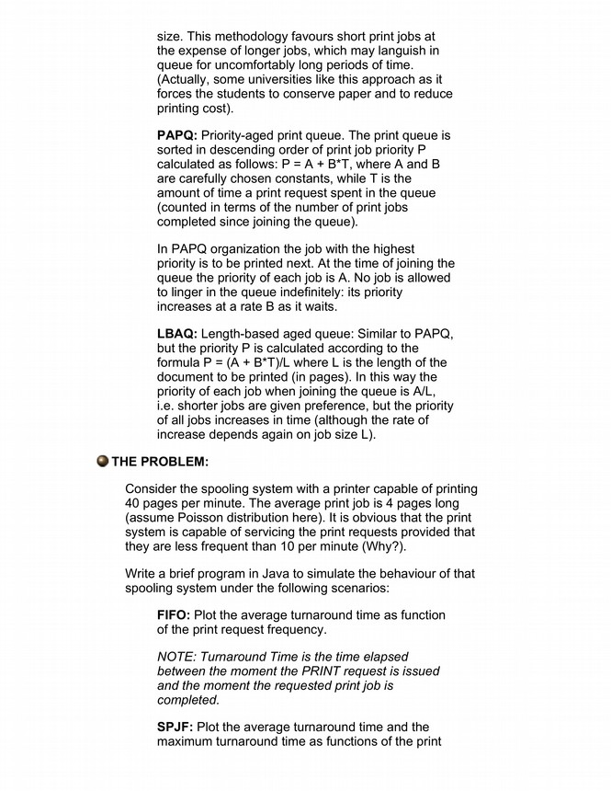
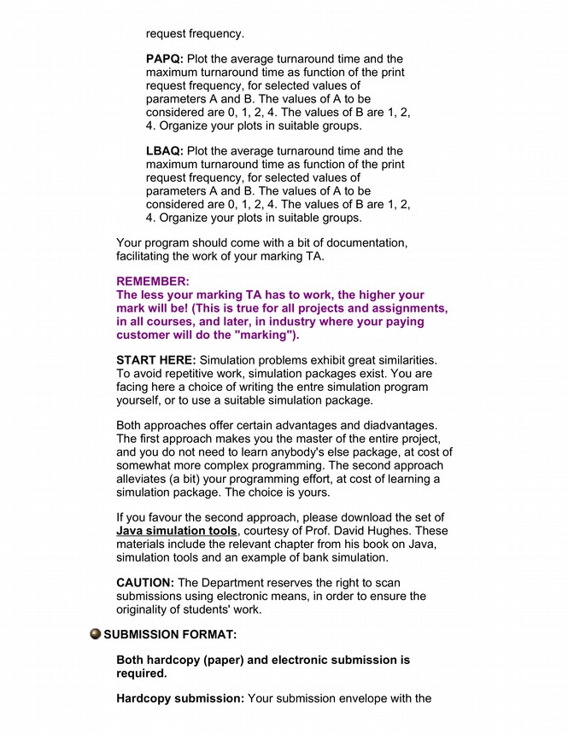
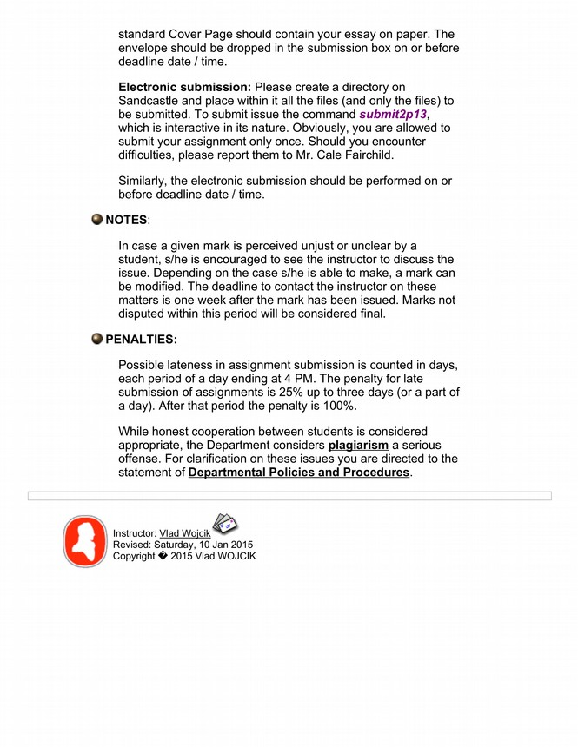

Objective
private int getLength_Poisson ( ) {
double L = Math.exp(-AVE_LENGTH);
double p = 1.0;
int k = 0;
do {
k++;
p *= Math.random();
} while (p > L);
return k - 1;
}
The getLength_Poisson() function of the PrintJob Object class.
Determine the optimal queue type for a simple printer SPOOLing system.

The PrintSim simulation program was written to answer this question. Running the simulation creates sample data that is converted to the plots that are analyzed and discussed in this report.

The Software

Usage
Simulation values are given from the command line at execution time. This can be job by executing the following command from the folder that PrintSim.jar is saved to.

java -jar PrintSim.jar <Num Print Jobs> <Num Iterations>

The default values are both 100 if none are given. The number of iterations used for the data in this report however, was 1000.

The Simulation
Given that we know the average printer is capable of printing pages at a rate of 40 pages per minute and that the average print job is 4 pages, we can know that a printer is capable of servicing print requests as long as they occur less frequent than 10 pages per minute (every 6 seconds). The time intervals used in this simulation are ones which are in a relatively small range of 6 seconds (the set of millisecond intervals {10000, 9500, 9000, 8500, 8000, 7500, 7000, 6500, 6000, 5500, 5000, 4500, 4000, 3500, 3000, 2500, 2000, 1500, 1000, 500, 0}).

Due to the potential for the queue to grow without bound, a maximum number of jobs must be given. As stated above; this is given via the command line arguments and the default is 100.

If there are print jobs currently in the queue, then the “printer” is started on a separate thread. This allows for jobs to be simultaneously entered into the queue as well as removed form the queue. To deal with concurrency issues; a binary semaphore was introduced with must be acquired prior to all operations on the queue (addition, deletion, and updating).

The simulation is run for all 21 intervals, for each queue type, calculating the maximum and average turnaround times for the print jobs. The data is temporarily stored, and the simulation is rerun for a given number of times. For the data used in this report, the simulation was run 1000 times.

All data is then compiled and the average maximum and average average turnaround times are calculated for each interval of each queue type. This data is then plotted and saved as a .PNG image in the same directory as PrintSim.jar. A log of the print job lengths are kept in log.txt.

Print Job Creation
The job's lengths are set at the start of each simulation iteration and are given by the getLength_Poisson() function of the PrintJob object class.

This function is implemented using Donald Knuth's algorithm for generating Poisson-distributed random values.

The Clock
The clock object is a simply a long value that is incremented by the amount of time that should elapse before proceding with the program execution. This is done any time an event occurs that would take any measurable amount of time. For this simulation, those events are the time between submitting print jobs and the time it takes for printjobs to print.

The print jobs take the current value from the clock at the time of their creation and the time of their death, after all their pages have been printed.

The turnaround time for any job can then be calculated as:

T_{turnaround} = T_{Death} – T_{Birth}

Queue Implementations
Four different queue types were implemented in this simulation:

FIFO | First-In, First-Out | The print jobs are printed in the order in which the print requests were sent.
SPJF | Shortest Print Job First | Print jobs are inserting into the queue in ascending order according to their job length.
PAPQ | Priority-Aged Print Queue | The print queue is sorted in descending order by priority  P = A + B*T, where T is the amount of time that the job has been in the queue for.
LBAQ | Length-Based Age Queue | The print queue is sorted in descending order by priority  p = (A + B*T)/L , where L is the length of the print job.

For the two queue implementations requiring A and B values, the values:

A = {0, 1, 2, 4}
B = {1, 2, 4}

were used. This essentially creates 12 different functions for each of the two queues, resulting in a total of 26 different queues that are created for this simulation.

Plots
A total of 26 different plots are created by the simulation software. They are saved to the /Plots/ folder of the directory in which PrintSim.jar was executed.

The first plot corresponds to the FIFO queue type, and the second to the SPJF queue type. Plots 3 through 14 correspond to the 12 PAPQ implementations, and plots 15 through 26 correspond to the 12 LBAQ implementations.

Libraries Used
Apache Commons IO | File and folder deletion | http://commons.apache.org/proper/commons-io/
XChart | Plot creation | http://xeiam.com/xchart/

Known Issue
As of now, I have been unable to resolve what I believe is a deadlock caused by some race condition at the beginning of the execution of the simulation.

This bug seems to occur about one in every four executions. If the bug occurs, the simulation successfully creates the print jobs for the first iteration, but fails to add them to the queue. The SPOOLER is then stuck waiting for the the jobs to be added.

However, if the simulation succeeds for the first iteration then the program will execute exactly as intended for all remaining iterations.

As I no longer have time to debug this issue, a work around is to monitor the program for about 10 seconds until the message “Running iteration 2” appear in the console. If the message takes longer than 10 seconds to appear, then it is likely that a deadlock has been reached. Killing the process, re-executing it, and praying, is the current solution.

Analysis
As previously stated, the simulation was run for 100 print jobs, 1000 times. The plots created by the simulation are below.

Plots

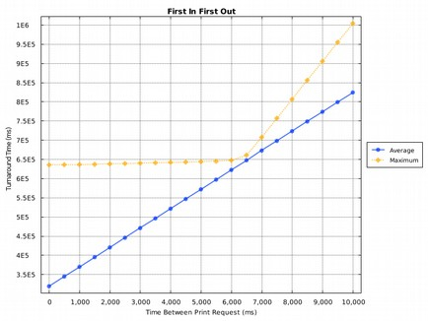
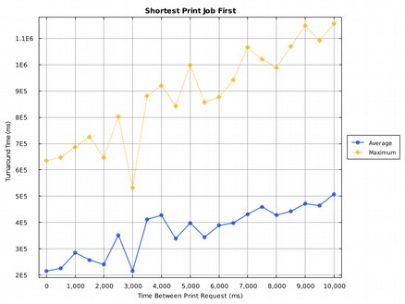
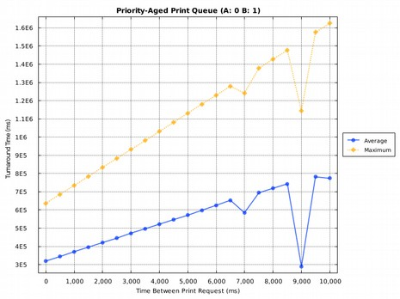
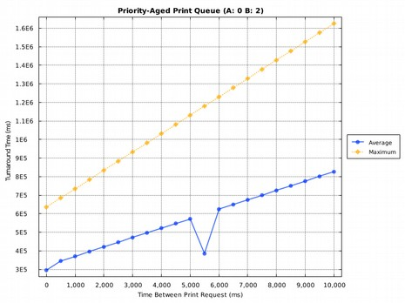
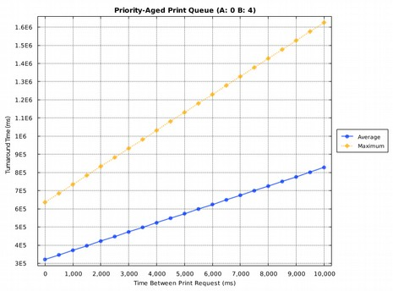
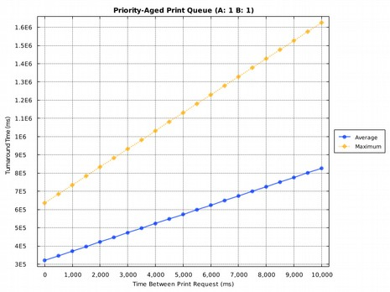
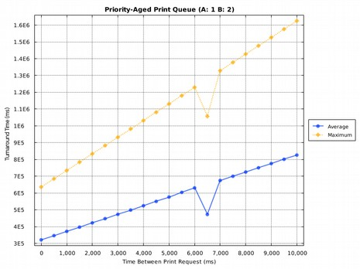
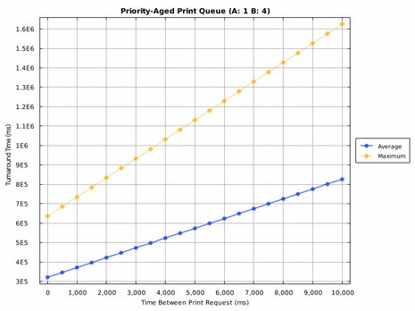
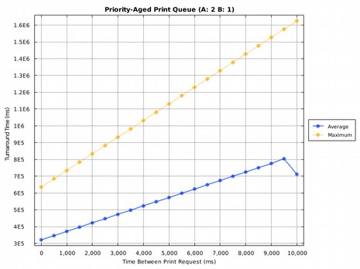
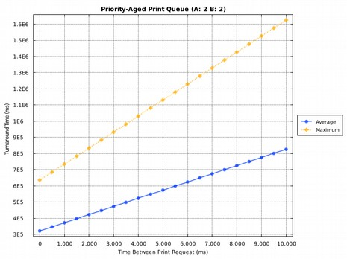
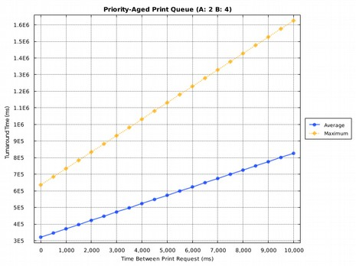
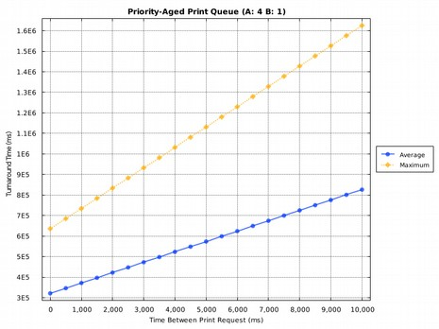
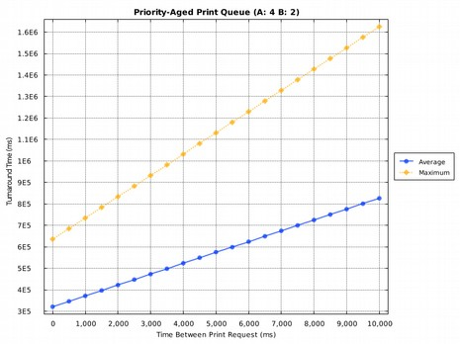
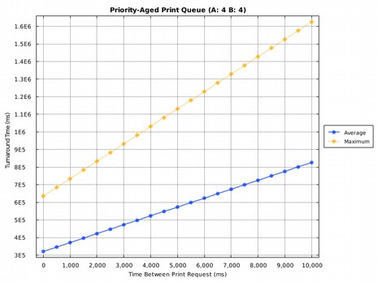
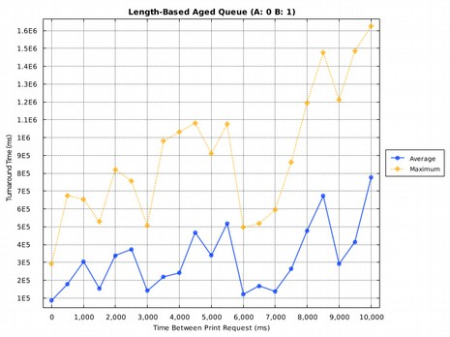
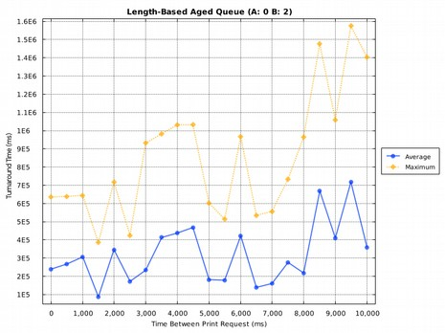
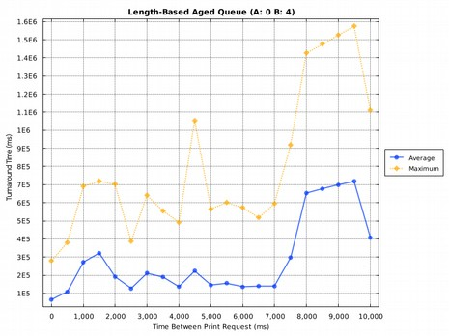
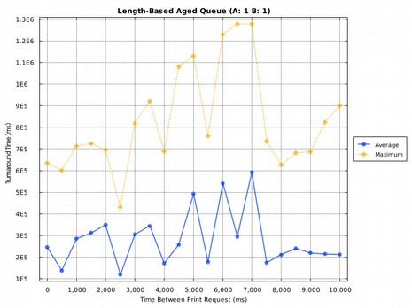
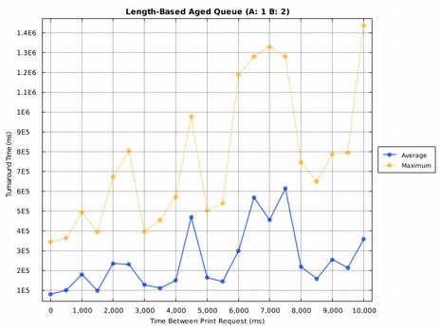
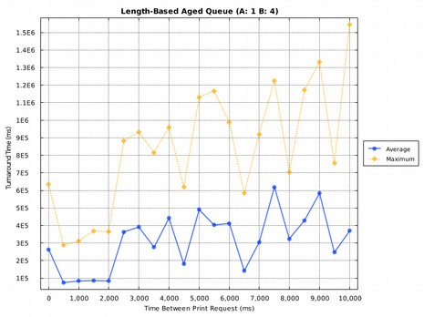
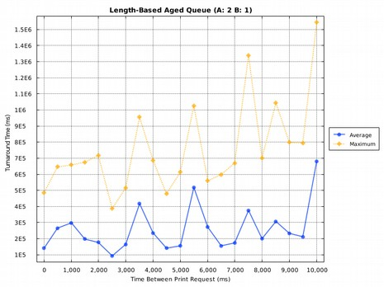
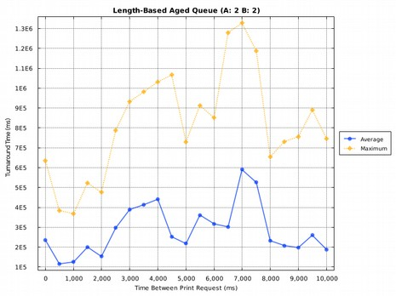
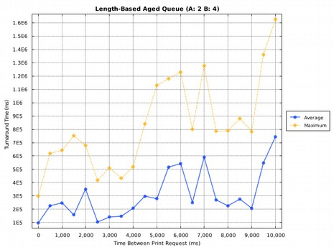
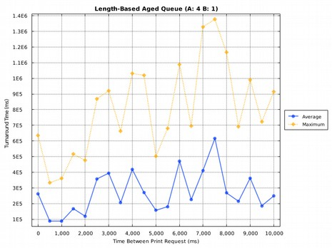
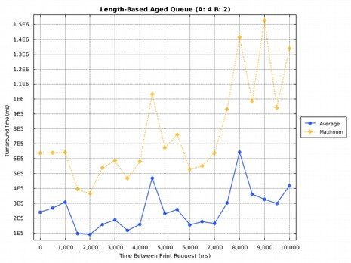
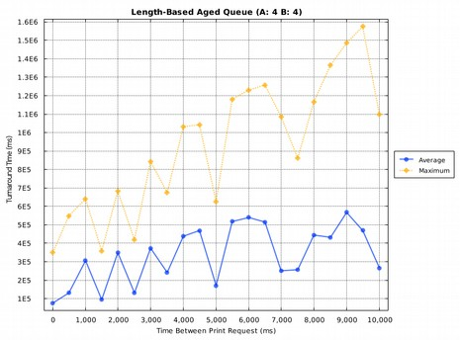

Discussion
Looking at the data for the FIFO queue type – The first graph – we can see that the results are pretty much as expected. The average turn around time for jobs is increasing uniformly as time between jobs increases. We see a sharp increase in maximum turnaround time as the print job frequency is decreased. This queue type also has an advantage over the others as there is no reordering of the queue necessary, and therefore no overhead.

The SPJF queue type significantly lowers the average turnaround time for the jobs. This makes sense as the average job will be shorter – around 4 pages. They will be printed first and as such be in the queue for a shorter period of time. The maximum turnaround time is on average higher than the FIFO. This is because on the occasions that large print jobs are sent to the SPOOLER they are held in the queue for a long time before being printed.

The PAPQ type is the least exciting discovery of them all. Outlier values can be see on several of the plots of this type. However looking at the general trend we can see that it appears as though it acts exactly the same as the FIFO queue regardless of the A and B values given. It is interisting to note however that the turnaround times are slightly better for all 12 queues – which doesnt necessarily make sense. The oldest job in the queue will have been the one that was added “first”, making it obvious that this queue type should behave the same as FIFO.

Finally we come to the most interesting data plots; the LBAQ SPOOLer type. All of the values of all of these plots are a significant improvement over the FIFO and PAPQ types. The A and B values do not seem to have any effect on the queue, so an A value of 0 and a B value of 1 would be the simplest implementation of this queue.

Comparisons
The SPJF queue type is a more uniform and predicatable type, but the average turnaround time is slightly worse than the LBAQ. If this queue was to be servicing less frequent jobs, with on average relatively short job lengths then the SPJF queue is likely a very efficient model to choose.

However, if there is potential for the printer to be under a heavy load, then the SPJF queue will force large jobs to the end of the queue, potentially for a ridiculously unfair amount of time. As stated in the project outline, this model is favoured by some (like universities for example) as it forces users to cut down on paper being used. However if this is not a goal of the queue than the encouragement does not make sense.

Even under heavy loads, the LBAQ will process long jobs as soon as they have been in the queue for a resonable amount of time. Priority is still given to short jobs, however long jobs will not be made to wait an unreasonable amount of time in the queue.

Conclusion
In conclusion it is safe to say that the LBAQ type is the queue type to choose as it places focus on both length of job and time in queue.

This most likely will only matter in special circumstances where there is a potential for extremely frequent job requests. For the printer in my house, a FIFO queue is perfectly acceptable as it requires no overhead or reorganizing. In a university trying to encourage students not to waste paper, the SPJF queue is the obvious choice.

It is important to fully understand the applications and goals of the print queue prior to determining the queue type to use. If the applications are unknown then it may be wise to use the LBAQ type as the default as it is always the most fair is servicing, and on average very efficient.

PrintSim Source Code

Simulate.java
- package Simulate;
- import java.io.*;
- import java.math.BigInteger;
- import java.util.ListIterator;
- import java.util.concurrent.Semaphore;
- import org.apache.commons.io.FileUtils;
- import com.xeiam.xchart.*;
- import List.DNode;
- import PrintJobs.PrintJob;
- import Spool.Spooler;
- /**
- * Simulate main Class Is the main "driver" for the print simulation.
- *
- * See documentation for use instructions.
- *
- * COSC 2P13 - Final Project
- * April 2015
- * Matt Laidman
- * 5199807, ml12ef
- *
- * @author Matt Laidman (5199807)
- * @version 1.0 (April, 2015)
- */
- @SuppressWarnings("all") // Only warning is ignored return value of File.mkdir()
- public class Simulate {
- private static int NUM_JOBS = 100;
- private static int NUM_LOOPS = 100;
- private int AS[] = {0, 1, 2, 4};
- private int BS[] = {1, 2, 4};
- public static Semaphore mutex = new Semaphore(1);
- public static DNode cData;
- public static boolean qFlag;
- public static SimClock clock;
- private PrintJob jobs[];
- private PrintWriter log;
- /**
- * Simulate constructor calls the appropriate functions to simulate
- * the data and plot it.
- */
- public Simulate() {
- int c = 1;
- int p;
- PrintWriter out;
- new File("Data").mkdir();
- try {
- log = new PrintWriter(new FileOutputStream(new File("log.txt"), true));
- } catch (FileNotFoundException e) {
- e.printStackTrace();
- return;
- }
- for (int i = 0 ; i < NUM_LOOPS ; i++) {
- System.out.println("Running iteration " + (i+1));
- DNode data = new DNode();
- cData = data;
- clock = new SimClock();
- jobs = getData(NUM_JOBS);
- log.println("Sample Print Job Lengths:");
- p = 1;
- for (PrintJob job : jobs) {
- log.print(job.getLength() + "\t");
- if (p % 10 == 0) {
- log.println();
- }
- p++;
- }
- doSimulate(1, 0, 0);
- doSimulate(2, 0, 0);
- for (int a : AS) {
- for (int b : BS) {
- doSimulate(3, a, b);
- }
- }
- for (int a : AS) {
- for (int b : BS) {
- doSimulate(4, a, b);
- }
- }
- log.println("Time Elapsed: " + clock.getTime() + "ms");
- while (new File("Data/data" + c + ".txt").exists()) {
- c++;
- }
- try {
- out = new PrintWriter("Data/data" + c + ".txt");
- } catch (FileNotFoundException e) {
- e.printStackTrace();
- return;
- }
- log.println("\nFinal Data:");
- cData = data;
- while (cData.next != null) {
- log.println("Queue type: " + cData.type + "\tA value: " + cData.a + "\tB value: " + cData.b +
- "\tFrequency: " + cData.frequency + "ms" + (cData.frequency == 0 ? "\t" : "") +
- "\tAverage turnaround: " + cData.average + "ms\tMaximum turnaround: " + cData.maximum + "ms");
- out.println(Integer.toString(cData.type));
- out.println(Integer.toString(cData.a));
- out.println(Integer.toString(cData.b));
- out.println(Integer.toString(cData.frequency));
- out.println(Long.toString(cData.average));
- out.println(Long.toString(cData.maximum));
- cData = cData.next;
- }
- out.close();
- }
- System.out.println("\nCreating Plots.");
- MakeGraphs(c);
- System.out.println("\nSimulation Complete.\n");
- try {
- FileUtils.deleteDirectory(new File("Data"));
- } catch (IOException e) {
- e.printStackTrace();
- }
- }
- /**
- * For each time interval, the doSimulate function creates the queues with
- * the given type, a and b values. It then adds the jobs to the queue, adding
- * the appropriate interval time elapsed to the clock.
- *
- * @param qType - The type of queue. Refer to documentation
- * @param a - The current a value to use
- * @param b - The currrent b value to use
- */
- private void doSimulate (int qType, int a, int b) {
- int times[] = {10000, 9500, 9000, 8500, 8000, 7500, 7000, 6500, 6000, 5500, 5000, 4500, 4000,
- 3500, 3000, 2500, 2000, 1500, 1000, 500, 0};
- for (int t : times) {
- Spooler spool = new Spooler(qType, a, b);
- qFlag = true;
- for (PrintJob job : jobs) {
- job.birth();
- try {
- mutex.acquire();
- try {
- spool.print(job);
- clock.addTime(t);
- } finally {
- mutex.release();
- }
- } catch(InterruptedException e) {
- e.printStackTrace();
- }
- }
- qFlag = false;
- try {
- spool.join();
- } catch (InterruptedException e) {
- e.printStackTrace();
- }
- cData.type = qType;
- cData.a = a;
- cData.b = b;
- cData.frequency = t;
- cData.next = new DNode();
- cData = cData.next;
- }
- }
- /**
- * getData creates the PintJob array the size of the given requestSize.
- *
- * @param requestSize - The number of jobs to create
- * @return Array of printjobs.
- */
- private PrintJob[] getData (int requestSize) {
- PrintJob jobs[] = new PrintJob[requestSize];
- for (int i = 0 ; i < requestSize ; i++) {
- jobs[i] = new PrintJob();
- }
- return jobs;
- }
- /**
- * makeGraphs function calls all functions required to build the plots.
- *
- * @param c value to use incase previous execution was halted and temporary
- * data files already exist (c = num left over files)
- */
- private void MakeGraphs (int c) {
- BufferedReader br;
- FileReader fr;
- GraphData simData[] = new GraphData[NUM_LOOPS];
- for (int i = c ; i < c + NUM_LOOPS ; i++) {
- try {
- fr = new FileReader("Data/data" + c + ".txt");
- } catch (FileNotFoundException e) {
- e.printStackTrace();
- return;
- }
- br = new BufferedReader(fr);
- simData[i - c] = getData(br);
- }
- if (NUM_LOOPS == 1) {
- buildPlots(simData[0]);
- } else {
- buildPlots(getAverageData(simData));
- }
- }
- /**
- * getAverageData function compiles the temporary data files into and calculates the averages.
- *
- * @param simData - All sim data read from the data files
- * @return A GraphData object containg the averaged data
- */
- private GraphData getAverageData (GraphData simData[]) {
- GraphData data = new GraphData();
- GraphData head = data;
- ListIterator<Long> iterator, iterator2;
- int j;
- long item;
- BigInteger z = BigInteger.ZERO;
- for (int i = 0 ; i < NUM_LOOPS ; i++) {
- simData[i] = simData[i].next;
- }
- while (simData[0] != null) {
- BigInteger[] ave = {z, z, z, z, z, z, z, z, z, z, z, z, z, z, z, z, z, z, z, z, z};
- BigInteger[] max = {z, z, z, z, z, z, z, z, z, z, z, z, z, z, z, z, z, z, z, z, z};
- data.next = new GraphData();
- data = data.next;
- data.title = simData[0].title;
- data.a = simData[0].a;
- data.b = simData[0].b;
- data.xData = simData[0].xData;
- for (int i = 0 ; i < NUM_LOOPS ; i++) {
- iterator = simData[i].y1Data.listIterator();
- iterator2 = simData[i].y2Data.listIterator();
- j = 0;
- while (iterator.hasNext()) {
- item = iterator.next();
- ave[j] = ave[j].add(new BigInteger(Long.toString(item)));
- item = iterator2.next();
- max[j] = max[j].add(new BigInteger(Long.toString(item)));
- j++;
- }
- simData[i] = simData[i].next;
- }
- for (BigInteger bi : ave) {
- data.y1Data.add(bi.divide(new BigInteger(Integer.toString(NUM_LOOPS))).longValue());
- }
- for (BigInteger bi : max) {
- data.y2Data.add(bi.divide(new BigInteger(Integer.toString(NUM_LOOPS))).longValue());
- }
- }
- return head;
- }
- /**
- * getData function parses the temporary data files and adds it
- * to a graph data object.
- *
- * @param br The file to read
- * @return The GraphData object of the file
- */
- private GraphData getData (BufferedReader br) {
- String line;
- GraphData data, head;
- data = new GraphData();
- head = data;
- for (int i = 0 ; i < 26 ; i++) {
- data.next = new GraphData();
- data = data.next;
- for (int j = 0 ; j < 21 ; j++) {
- try {
- line = br.readLine(); // First line is Queue Type
- switch (Integer.parseInt(line)) {
- case 1:
- data.title = "First In First Out";
- break;
- case 2:
- data.title = "Shortest Print Job First";
- break;
- case 3:
- data.title = "Priority-Aged Print Queue";
- break;
- case 4:
- data.title = "Length-Based Aged Queue";
- break;
- }
- line = br.readLine(); // Second is a
- data.a = Integer.parseInt(line);
- line = br.readLine(); // Third is b
- data.b = Integer.parseInt(line);
- line = br.readLine(); // Fourth is Frequency
- data.xData.add(Integer.parseInt(line));
- line = br.readLine(); // Fifth is Average
- data.y1Data.add(Long.parseLong(line));
- line = br.readLine(); // Sixth is Maximum
- data.y2Data.add(Long.parseLong(line));
- } catch (IOException e) {
- e.printStackTrace();
- return null;
- }
- }
- }
- return head;
- }
- /**
- * The function to build the plots.
- *
- * @param data - The averaged data
- */
- private void buildPlots (GraphData data) {
- data = data.next;
- int c = 1, count = 1;
- while (new File("Plots" + c).exists()) {
- c++;
- }
- new File("Plots" + c).mkdir();
- while (data != null) {
- Chart chart = new ChartBuilder().width(800).height(600).theme(StyleManager.ChartTheme.Matlab)
- .title(data.title + ((data.a == 0 && data.b == 0) ? "" : " (A: " + data.a + " B: " + data.b + ")"))
- .xAxisTitle("Time Between Print Request (ms)").yAxisTitle("Turnaround Time (ms)").build();
- chart.addSeries("Average", data.xData, data.y1Data);
- Series series2 = chart.addSeries("Maximum", data.xData, data.y2Data);
- series2.setLineStyle(SeriesLineStyle.DOT_DOT);
- try {
- BitmapEncoder.saveBitmap(chart, "Plots" + c + "/plot" + count, BitmapEncoder.BitmapFormat.PNG);
- } catch (IOException e) {
- e.printStackTrace();
- return;
- }
- count++;
- data = data.next;
- }
- log.println("Plots saved to /plots" + c + "\n");
- log.close();
- }
- /**
- * main function assigns the command line parameters if they are given.
- */
- public static void main(String[] args) {
- if (args.length > 0) {
- NUM_JOBS = Integer.parseInt(args[0]);
- }
- if (args.length > 1) {
- NUM_LOOPS = Integer.parseInt(args[1]);
- }
- new Simulate();
- }
- }

SimClock.java
- package Simulate;
- /**
- * Created by matt on 28/03/15.
- */
- public class SimClock {
- private long time;
- public SimClock ( ) {
- time = 0;
- }
- public long getTime ( ) {
- return time;
- }
- public void addTime (long t) {
- time+=t;
- }
- }

GraphData.java
- package Simulate;
- import java.util.ArrayList;
- import java.util.List;
- /**
- * Created by matt on 26/03/15.
- */
- public class GraphData {
- public String title;
- public int a, b;
- public List<Integer> xData;
- public List<Long> y1Data;
- public List<Long> y2Data;
- public GraphData next;
- public GraphData() {
- xData = new ArrayList<Integer>();
- y1Data = new ArrayList<Long>();
- y2Data = new ArrayList<Long>();
- next = null;
- }
- }

PrintJob.java
- package PrintJobs;
- import Simulate.Simulate;
- /**
- * PrintJob class is the PrintJob data type used in the PrintSim SPOOLer project.
- *
- * @author Matt Laidman (5199807)
- * @version 1.0 (January, 2015)
- */
- public class PrintJob {
- private final int AVE_LENGTH = 4;
- private int length;
- private long birth, death;
- /**
- * Public constructor to create a PrintJob with random pages.
- */
- public PrintJob ( ) {
- setLength();
- }
- /**
- *
- */
- public long timeAlive ( ) {
- return (death == 0) ? (Simulate.clock.getTime() - birth) : (death - birth);
- }
- /**
- * die function should only be invoked when a PrintJob has been completed.
- * It will set the current system time to the death variable.
- */
- public void die ( ) {
- death = Simulate.clock.getTime();
- }
- /**
- * getLength function returns the length of the print job.
- *
- * @return int The length of the print job
- */
- public int getLength ( ) {
- return length;
- }
- /**
- * setLength function sets the page length of the print job.
- */
- private void setLength ( ) {
- int l;
- do {
- l = getLength_Poisson();
- if (l != 0)
- length = l;
- } while (l == 0);
- }
- /**
- * getBirth function sets the current system time to the birth variable.
- */
- public void birth ( ) {
- birth = Simulate.clock.getTime();
- }
- /**
- * Private getLength_Poisson function returns a random integer with a poisson
- * distribution from a given seed integer (AVE_LENGTH).
- *
- * Algorithm used is Knuth's pseudocode for generating Poison-distributed random
- * variables found at:
- *
- * http://en.wikipedia.org/wiki/Poisson_distribution#Generating_Poisson-distributed_random_variables
- *
- * @return int Random poisson distributed value.
- */
- private int getLength_Poisson ( ) {
- double L = Math.exp(-AVE_LENGTH);
- double p = 1.0;
- int k = 0;
- do {
- k++;
- p *= Math.random();
- } while (p > L);
- return k - 1;
- }
- }

Spooler.java
- package Spool;
- import PrintJobs.PrintJob;
- import Queues.*;
- /**
- * Spooler class is a mask for the PrintQueue class. It ass the jobs to the queue
- * and starts the dequeueing thread if it is not already started.
- *
- * It also creates the appropriate queue type.
- *
- * @author Matt Laidman (5199807)
- * @version 1.0 (January, 2015)
- */
- public class Spooler {
- static final int PAGES_PER_MINUTE = 40;
- public static Queue printQueue;
- private PrintQueue qThread = new PrintQueue();
- public Spooler (int queueType, int a, int b) {
- createQueue(queueType, a, b);
- }
- public void print (PrintJob j) {
- printQueue.enqueue(j);
- if (!qThread.isAlive()) {
- qThread.start();
- }
- }
- public void join ( ) throws InterruptedException {
- try {
- qThread.join();
- } catch (InterruptedException e) {
- e.printStackTrace();
- }
- }
- private void createQueue (int i, int a, int b) {
- switch (i) {
- case 1:
- printQueue = new FIFOQueue();
- break;
- case 2:
- printQueue = new SPJFQueue();
- break;
- case 3:
- printQueue = new PAPQQueue(a, b);
- break;
- case 4:
- printQueue = new LBAQQueue(a, b);
- break;
- default:
- throw new NoSuchQueueException();
- }
- }
- }

PrintQueue.java
- package Spool;
- import PrintJobs.PrintJob;
- import Simulate.Simulate;
- import java.math.BigInteger;
- /**
- * Print queue thread dequeues PrintJobs from the queue, adding the appropriate time
- * to the clock.
- *
- * This class is threaded so that PrintJobs can be added to the queue will others are
- * being dequeued.
- *
- * @author Matt Laidman (5199807)
- * @version 1.0 (January, 2015)
- */
- public class PrintQueue extends Thread {
- private long max;
- private BigInteger total;
- private int count;
- public PrintQueue ( ) {
- max = 0;
- total = new BigInteger("0");
- count = 0;
- }
- public void run ( ) {
- PrintJob j;
- while (Simulate.qFlag || !Spooler.printQueue.isEmpty()) {
- if (!Spooler.printQueue.isEmpty()) {
- try {
- Simulate.mutex.acquire();
- try {
- Spooler.printQueue.update();
- } finally {
- Simulate.mutex.release();
- }
- } catch(InterruptedException e) {
- e.printStackTrace();
- }
- try {
- Simulate.mutex.acquire();
- try {
- j = Spooler.printQueue.dequeue();
- Simulate.clock.addTime(j.getLength() * (60000 / Spooler.PAGES_PER_MINUTE));
- j.die();
- count++;
- total = total.add(new BigInteger(String.valueOf(j.timeAlive())));
- if (max < j.timeAlive()) {
- max = j.timeAlive();
- }
- } finally {
- Simulate.mutex.release();
- }
- } catch(InterruptedException e) {
- e.printStackTrace();
- }
- }
- }
- Simulate.cData.maximum = max;
- Simulate.cData.average = getAverage();
- }
- private long getAverage ( ) {
- return (count == 0) ? 0 : total.divide(new BigInteger(String.valueOf(count))).longValue();
- }
- }

NoSuchQueueException.java
- package Spool;
- /**
- * NoSuchQueueException is thrown by Queue data type classes if overflow occurs.
- *
- * @author Matt Laidman (5199807)
- * @version 1.0 (January, 2015)
- */
- class NoSuchQueueException extends RuntimeException {
- public NoSuchQueueException ( ) {
- super("No such queue type!");
- }
- public NoSuchQueueException (String arg) {
- super(arg);
- }
- }

Queue.java
- package Queues;
- import PrintJobs.*;
- /**
- * The Queue interface defines the queue data types used in the printer driver simulation.
- *
- * @author Matt Laidman (5199807)
- * @version 1.0 (January 2015)
- */
- public interface Queue {
- /**
- * enqueue function enters a given item into the queue.
- * QueueOverflowException is thrown if the queue is full.
- *
- * @param p The item to add to the queue.
- */
- public void enqueue (PrintJob p);
- /**
- * dequeue function removes the front item from the queue and returns it.
- * QueueUnderflowException is thrown if the queue is empty.
- *
- * @return PrintJob The item at the front of the queue.
- */
- public PrintJob dequeue ( );
- /**
- * update function can be called to run a sorting algorithm over the
- * queue to update it's order.
- */
- public void update ( );
- /**
- * front function does not remove the item from the queue but returns a pointer to the item.
- * QueueUnderflowException is thrown if the queue is empty.
- *
- * @return PrintJob The item at the front of the queue.
- */
- public PrintJob front ( );
- /**
- * length function returns the length of the queue.
- *
- * @return int The length of the queue.
- */
- public int length ( );
- /**
- * isEmpty function returns true if the queue is empty. Otherwise it return false.
- *
- * @return boolean True if queue is empty.
- */
- public boolean isEmpty ( );
- }

QNode.java
- package Queues;
- import PrintJobs.*;
- /**
- * QNode class is the Queue Node used in the building and traversal of the
- * queues for the printsim project.
- *
- * ***************** Global Variables *****************
- *
- * job - The contents of the node.
- * next - The next node in the list.
- *
- * @author Matt Laidman (5199807)
- * @version 1.0 (January, 2014)
- */
- class QNode {
- public PrintJob job;
- public QNode next;
- /**
- * Public constructor to create a QNode from a key with a null next pointer.
- *
- * @param job The data in the QNode.
- */
- public QNode (PrintJob job) {
- this(job, null);
- }
- /**
- * Private constructor to set values of package private variables.
- *
- * @param job The data in the QNode.
- * @param next The next node in the list.
- */
- private QNode (PrintJob job, QNode next) {
- this.job = job;
- this.next = next;
- }
- }

FIFOQueue.java
- package Queues;
- import PrintJobs.PrintJob;
- /**
- * FIFOQueue class is the 'first in first out' queue type used in the PrintSim
- * SPOOLer project.
- *
- * ***************** Variables *****************
- *
- * front - Front node in queue
- * back - back node in queue
- * count - Number of nodes in queue
- *
- * @author Matt Laidman (5199807)
- * @version 1.0 (January, 2014)
- */
- public class FIFOQueue implements Queue {
- private QNode front; // front node in the queue
- private QNode back; // rear node in the queue
- private int count; // number of nodes in the queue
- /**
- * Constructor to create new empty queue.
- */
- public FIFOQueue ( ) {
- front = null;
- back = null;
- count = 0;
- }
- /**
- * enqueue function adds an item to the end of the queue.
- *
- * @param p The item to add to the queue.
- */
- public void enqueue (PrintJob p) {
- QNode t = new QNode(p);
- if (count == 0)
- front = t;
- else
- back.next = t;
- back = t;
- count++;
- }
- /**
- * dequeue function removes the first item from the queue and returns it.
- *
- * @return The front item from the queue
- */
- public PrintJob dequeue ( ) {
- PrintJob p;
- if (count == 0)
- throw new QueueUnderflowException();
- else {
- p = front.job;
- count--;
- if (count == 0) {
- back = null;
- front = null;
- } else {
- front = front.next;
- }
- return p;
- }
- }
- /**
- * update function can be called to run a sorting algorithm over the
- * queue to update it's order.
- */
- public void update ( ) { } // Update function unnecessary for FIFO
- /**
- * front function leaves the front item in the queue and returns the key of that item.
- *
- * @return The front item from the queue
- */
- public PrintJob front ( ) {
- if (count == 0)
- throw new QueueUnderflowException();
- else
- return front.job;
- }
- /**
- * length function returns the length of the queue.
- *
- * @return The length of the queue.
- */
- public int length ( ) {
- return count;
- }
- /**
- * isEmpty function returns true if the queue is empty, otherwise false.
- *
- * @return True if queue is empty.
- */
- public boolean isEmpty ( ) {
- return count == 0;
- }
- }

SPJFQueue.java
- package Queues;
- import PrintJobs.*;
- /**
- * SPJFQueue class is the 'shortest print job first' queue type used in the PrintSim
- * SPOOLer project.
- *
- * ***************** Variables *****************
- *
- * front - Front node in queue
- * back - back node in queue
- * count - Number of nodes in queue
- *
- * @author Matt Laidman (5199807)
- * @version 1.0 (January, 2014)
- */
- public class SPJFQueue implements Queue {
- private QNode front; // front node in the queue
- private QNode back; // rear node in the queue
- private int count; // number of nodes in the queue
- /**
- * Constructor to create new empty queue.
- */
- public SPJFQueue ( ) {
- front = null;
- back = null;
- count = 0;
- }
- /**
- * enqueue function adds an item to the end of the queue.
- *
- * @param p The item to add to the queue.
- */
- public void enqueue (PrintJob p) {
- QNode ptr, prev, t;
- ptr = front;
- prev = null;
- t = new QNode(p);
- if (count == 0) {
- front = t;
- back = t;
- } else {
- while (ptr != null && t.job.getLength() >= ptr.job.getLength()) {
- prev = ptr;
- ptr = ptr.next;
- }
- if (prev == null) {
- t.next = front;
- front = t;
- } else {
- t.next = ptr;
- prev.next = t;
- if (t.next == null) {
- back = t;
- }
- }
- }
- count++;
- }
- /**
- * dequeue function removes the first item from the queue and returns it.
- *
- * @return The front item from the queue
- */
- public PrintJob dequeue ( ) {
- PrintJob p;
- if (count == 0)
- throw new QueueUnderflowException();
- else {
- p = front.job;
- count--;
- if (count == 0) {
- back = null;
- front = null;
- } else {
- front = front.next;
- }
- return p;
- }
- }
- /**
- * update function can be called to run a sorting algorithm over the
- * queue to update it's order.
- */
- public void update() {
- SPJFQueue t = new SPJFQueue();
- while (!this.isEmpty()) {
- t.enqueue(this.dequeue());
- }
- this.front = t.front;
- this.back = t.back;
- this.count = t.count;
- }
- /**
- * front function leaves the front item in the queue and returns the key of that item.
- *
- * @return The front item from the queue
- */
- public PrintJob front ( ) {
- if (count == 0)
- throw new QueueUnderflowException();
- else
- return front.job;
- }
- /**
- * length function returns the length of the queue.
- *
- * @return The length of the queue.
- */
- public int length ( ) {
- return count;
- }
- /**
- * isEmpty function returns true if the queue is empty, otherwise false.
- *
- * @return True if queue is empty.
- */
- public boolean isEmpty ( ) {
- return count == 0;
- }
- }

PAPQQueue.java
- package Queues;
- import PrintJobs.PrintJob;
- /**
- * Created by matt on 20/01/15.
- *
- */
- public class PAPQQueue implements Queue {
- private QNode front; // front node in the queue
- private QNode back; // rear node in the queue
- private int count; // number of nodes in the queue
- private int a, b; // Constants
- /**
- * Constructor to create new empty queue.
- */
- public PAPQQueue (int a, int b) {
- this.a = a;
- this.b = b;
- front = null;
- back = null;
- count = 0;
- }
- /**
- * enqueue function adds an item to the end of the queue.
- *
- * @param p The item to add to the queue.
- */
- public void enqueue (PrintJob p) {
- QNode ptr, prev, t;
- ptr = front;
- prev = null;
- t = new QNode(p);
- if (count == 0) {
- front = t;
- back = t;
- } else {
- while (ptr != null && (a + (b*t.job.timeAlive())) >= (a + (b*ptr.job.timeAlive()))) {
- prev = ptr;
- ptr = ptr.next;
- }
- if (prev == null) {
- t.next = front;
- front = t;
- } else {
- t.next = ptr;
- prev.next = t;
- if (t.next == null) {
- back = t;
- }
- }
- }
- count++;
- }
- /**
- * dequeue function removes the first item from the queue and returns it.
- *
- * @return The front item from the queue
- */
- public PrintJob dequeue ( ) {
- PrintJob p;
- if (count == 0)
- throw new QueueUnderflowException();
- else {
- p = front.job;
- count--;
- if (count == 0) {
- back = null;
- front = null;
- } else {
- front = front.next;
- }
- return p;
- }
- }
- /**
- * update function can be called to run a sorting algorithm over the
- * queue to update it's order.
- */
- public void update() {
- PAPQQueue t = new PAPQQueue(a, b);
- while (!this.isEmpty()) {
- t.enqueue(this.dequeue());
- }
- this.front = t.front;
- this.back = t.back;
- this.count = t.count;
- }
- /**
- * front function leaves the front item in the queue and returns the key of that item.
- *
- * @return The front item from the queue
- */
- public PrintJob front ( ) {
- if (count == 0)
- throw new QueueUnderflowException();
- else
- return front.job;
- }
- /**
- * length function returns the length of the queue.
- *
- * @return The length of the queue.
- */
- public int length ( ) {
- return count;
- }
- /**
- * isEmpty function returns true if the queue is empty, otherwise false.
- *
- * @return True if queue is empty.
- */
- public boolean isEmpty ( ) {
- return count == 0;
- }
- }

LBAQQueue.java
- package Queues;
- import PrintJobs.PrintJob;
- /**
- * Created by matt on 20/01/15.
- *
- */
- public class LBAQQueue implements Queue {
- private QNode front; // front node in the queue
- private QNode back; // rear node in the queue
- private int count; // number of nodes in the queue
- private int a, b; // Constants
- /**
- * Constructor to create new empty queue.
- */
- public LBAQQueue (int a, int b) {
- this.a = a;
- this.b = b;
- front = null;
- back = null;
- count = 0;
- }
- /**
- * enqueue function adds an item to the end of the queue.
- *
- * @param p The item to add to the queue.
- */
- public void enqueue (PrintJob p) {
- QNode ptr, prev, t;
- ptr = front;
- prev = null;
- t = new QNode(p);
- if (count == 0) {
- front = t;
- back = t;
- } else {
- while (ptr != null && (a + (b*t.job.timeAlive()))/t.job.getLength() >=
- (a + (b*ptr.job.timeAlive()))/ptr.job.getLength()) {
- prev = ptr;
- ptr = ptr.next;
- }
- if (prev == null) {
- t.next = front;
- front = t;
- } else {
- t.next = ptr;
- prev.next = t;
- if (t.next == null) {
- back = t;
- }
- }
- }
- count++;
- }
- /**
- * dequeue function removes the first item from the queue and returns it.
- *
- * @return The front item from the queue
- */
- public PrintJob dequeue ( ) {
- PrintJob p;
- if (count == 0)
- throw new QueueUnderflowException();
- else {
- p = front.job;
- count--;
- if (count == 0) {
- back = null;
- front = null;
- } else {
- front = front.next;
- }
- return p;
- }
- }
- /**
- * update function can be called to run a sorting algorithm over the
- * queue to update it's order.
- */
- public void update() {
- LBAQQueue t = new LBAQQueue(a, b);
- while (!this.isEmpty()) {
- t.enqueue(this.dequeue());
- }
- this.front = t.front;
- this.back = t.back;
- this.count = t.count;
- }
- /**
- * front function leaves the front item in the queue and returns the key of that item.
- *
- * @return The front item from the queue
- */
- public PrintJob front ( ) {
- if (count == 0)
- throw new QueueUnderflowException();
- else
- return front.job;
- }
- /**
- * length function returns the length of the queue.
- *
- * @return The length of the queue.
- */
- public int length ( ) {
- return count;
- }
- /**
- * isEmpty function returns true if the queue is empty, otherwise false.
- *
- * @return True if queue is empty.
- */
- public boolean isEmpty ( ) {
- return count == 0;
- }
- }

QueueOverflowException.java
- package Queues;
- /**
- * QueueOverflowException is thrown by Queue data type classes if overflow occurs.
- *
- * @author Matt Laidman (5199807)
- * @version 1.0 (January, 2015)
- */
- class QueueOverflowException extends RuntimeException {
- public QueueOverflowException ( ) {
- super("Queue Overflow!");
- }
- public QueueOverflowException (String arg) {
- super(arg);
- }
- }

QueueUnderflowException.java
- package Queues;
- /**
- * QueueUnderflowException is thrown by Queue data type classes if underflow occurs.
- *
- * @author Matt Laidman (5199807)
- * @version 1.0 (January, 2015)
- */
- class QueueUnderflowException extends RuntimeException {
- public QueueUnderflowException ( ) {
- super("Queue Underflow!");
- }
- public QueueUnderflowException (String arg) {
- super(arg);
- }
- }

DNode.java
- package List;
- /**
- * DNode class is the List Node used in the building and traversal of the
- * data list.
- *
- * @author Matt Laidman (5199807)
- * @version 1.0 (October 21, 2014)
- */
- public class DNode {
- public int type;
- public int a;
- public int b;
- public long average;
- public long maximum;
- public int frequency;
- public DNode next;
- /**
- * Public constructor to create an DNode from a key with a null next pointer.
- */
- public DNode ( ) {
- this(0, 0, 0, null);
- }
- /**
- * Private constructor to set values of package private variables.
- *
- * @param average - Average time in queue
- * @param maximum - Maximum time in queue
- * @param frequency - Frequency of print request
- * @param next - next node in list
- */
- private DNode (long average, long maximum, int frequency, DNode next) {
- this.average = average;
- this.maximum = maximum;
- this.frequency = frequency;
- this.next = next;
- }
- }

Citations
"Commons IO - Commons IO Overview." Commons IO - Commons IO Overview. Accessed January 29, 2015. http://commons.apache.org/proper/commons-io/.

Knuth, Donald Ervin.The Art of Computer Programming. Reading (Mass.): Addison-Wesley, 1968.

Mahmoud, Qusay. "Concurrent Programming with J2SE 5.0." Concurrent Programming with J2SE 5.0. March 1, 2005. Accessed January 29, 2015. http://www.oracle.com/technetwork/articles/javase/index-140767.html.

"Poisson Distribution - Generating Poisson-distributed Random Variables." Wikipedia. Accessed January 29, 2015. http://en.wikipedia.org/wiki/Poisson_distribution#Generating_Poisson-distributed_random_variables.

"XChart." Xeiam. Accessed March 13, 2015. http://xeiam.com/xchart/.

"XChart Example Code." Xeiam. Accessed March 13, 2015. http://xeiam.com/xchart-example-code/.

